National Middle Schools’ Forum
‘The voice of the Middle Schools’
Newsletter: Autumn 2022

  www.middleschools.org | Executive Officer: Mr Mark Walker  20 Mattravers Way  Taunton  Somerset  TA1 3FR  Mobile: 07989 542762  e-mail: mark@walkereducation.co.uk
Dear Colleagues

I hope that this newsletter finds you all well across our Middle School community in England?

Everyone that I speak to in schools across the country tells me that times are tough. Being in education has always been challenging but we find ourselves immersed in a time post-pandemic, within a hard-hitting period financially for our country (and therefore more of our children living in poverty) and at a time where meeting the every-growing needs of young people has never been more difficult. I sense that we all need to ‘ride the wave’ over the coming terms to try and find a period of calm in schools that allows our communities to reset and find a kinder way forward.

One thing that I know, as Middle School people, is how proud we are of what we deliver. We never should forget this. Our education experience is like nothing else in this country. The fullness of our curriculum, the uniqueness of our environments, the offer we provide our Middle School children each day. Through the challenges, it is important to remember that as a school system we have something special and something that the highest percentages of our children talk so fondly about both when they’re in our care and furthermore once they have moved on to the next stage of their lives.

Over recent months, I have had the chance to visit a number of Middle Schools across the country. In June, I was lucky enough to have tours and meet colleagues in our most northern Middle Schools in Berwick-upon-Tweed. This was followed by the chance to visit colleagues in Morpeth and then Corbridge. It is the first time I have visited Northumberland and I look forward to going back very soon. I encourage others to do the same, the schools are superb and the people and scenery are just wonderful. Just a couple of weeks ago, I enjoyed the chance to spend time in Codsall Middle School and meet the delightful staff and children there. I remind all of you that I am here to support you and get to know your environments. Do invite me to come and see you as it truly is the best part of this role.
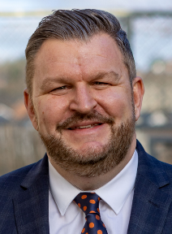
In the run up to Christmas, I wish you all a positive end to the term and look forward to writing to you in the Spring.

Best wishes

Mark

Thanks to Nigel
At our recent National Middle Schools Conference, we had the chance to celebrate the contribution of the wonderful Nigel Wyatt. Since 2002, Nigel has been the Forum’s Executive Officer and represented our system with great professionalism and honour.

Many of us will look back upon our time and will feel proud of our years, decade or maybe two or three decades or so in the Middle Schools system and our championing of it. Nigel has dedicated almost five decades to the Middle School system we hold so dear. I very much doubt there can be any more than a handful across our country who have given to Middle Schools what Nigel has.

For many that have worked with Nigel and the thousands of hours he has given to supporting Middle Schools, what is an absolute fact is Nigel’s legacy and contribution to Middle School education in this country will never be forgotten. 47 years as a Middle School man and 20 years as our Exec Officer. Thank you so much Nigel for all you have done for us.

National Conference 2022
Our National Middle Schools Conference occurred last month with Middle School leaders from across the country joining us for two days in Stratford upon Avon. The event included keynote speeches from Pam Burrows (the People Booster) and Robin Launder (the Behaviour Buddy). Our continued good links to national organisations also were maintained with sessions led by Andrew Warren (Regional Director for Wets Midlands) and Sandy Hayes (from Ofsted).
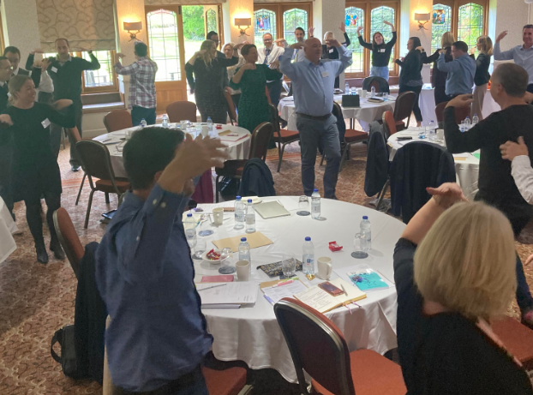
Pam Burrows, the People Booster, leads Middle School leaders in a variety of methods to support stress relief and programmes to aid our staff in managing workload.
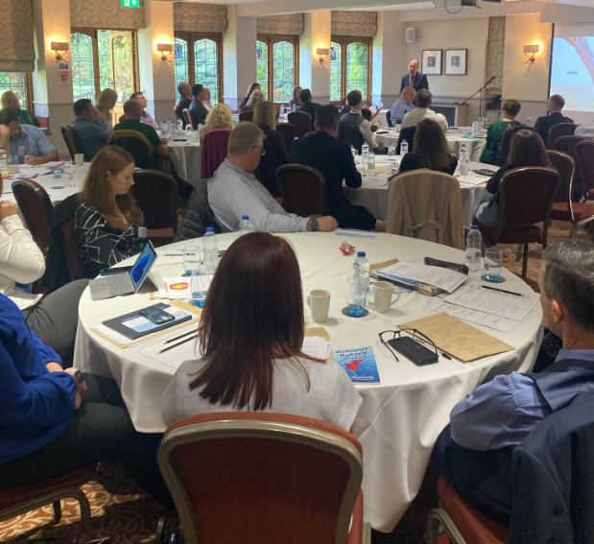

Regional Director for Education in the West Midlands, Andrew Warren, gives Middle School colleagues some clarity on aspects such as schools restructure and providing for the needs of children with special education needs and disabilities.

National Middle Schools Forum – Steering Committee

Meeting Dates - 10.30 a.m. at St Saviour’s Church, St George’s Square, Pimlico, SW1V 9AL

- Wednesday 9th November 2022
- Wednesday 8th March 2023
- Wednesday 7th June 2023

National Conference – Keynote Links

Both Pam Burrows and Robin Launder have provided colleagues across the country with links from the key messages and powerpoints from their sessions:

Pam Burrows
Website - Home (pamburrows.com)

Care Model - Links to various social media sites, website where they can sign up for the Monday Motivator, and a hidden webpage with a free PDF version of my Burnout Buster book, slides, videos, and useful book references as well as posters your HTs/their staff can print off to remind them of the CARE Model https://linktr.ee/pamburrows

Video on embedding the CARE Wellbeing Model after the training. https://youtu.be/inND6DMp1iM
Video from the HSE on reducing stress in the workplace. https://youtu.be/YtMPcsOZjpU

Robin Launder
Website - Home - Behaviour Buddy

Powerpoint slides - https://1drv.ms/p/s!AsQCtR5wnWotidNfgiQHHSpec4-fbQ?e=G1AI8e

Supporting Berwick-upon-Tweed Middle Schools

Tweedmouth and Berwick Middle schools have just launched a joint online campaign to Save Our Middle Schools.
The more people joining the Facebook group the higher the likelihood that the outcome of the next phase of County Council consultation will be successful for the area.
https://www.facebook.com/groups/416459523986052/?ref=share_group_link

Please do click on the tab above to find out more and lend your support.

National Middle Schools’ Forum – Steering Committee 2022/2023

Name | County | Contact details
Pete Bowers  Chair | Staffordshire | Codsall Middle School,  Wolverhampton Road, Stafffordshire, WV8 1PB  Tel: 01902 434145  Email: headteacher@codsall-middle.staffs.sch.uk
Darren Ayling  Vice Chair | Dorset | St Michael’s Church of England Middle School  Colehill Lane, Wimborne, Dorset. BH21 7AB  Tel: 01202 883433  Email: dayling@stmichaelsmiddle.org
David McGrath Treasurer | Somerset | Danesfield Church of England School,  North Road, Williton, Taunton, Somerset, TA4 4SW  Tel: 01984 632581  Email : DMcGrath817@wsat.org.uk
Zoe Linington | Central Bedfordshire | Edward Peake C of E (VC) Middle School  Potton Road, Biggleswade,Bedfordshire, SG18 0EJ  Tel: 01767 314562  Email: zlinington@edwardpeake.beds.sch.uk
Jenny Bullock | Northumberland | Ovingham Middle School  Ovingham, Prudhoe, Northumberland, NE42 6DE  Tel: 01661 833215  Email : jenny.bullock@ovinghammiddle.co.uk
Glen Bird | Northumberland | Berwick Middle School  Lovaine Terrace, Berwick upon Tweed, Northumberland, TD15 1LA  Telephone: 01289 306140  Email : glen.bird@berwick.northumberland.sch.uk
Chris Wright | Staffordshire | Christ Church Academy  Old Road, Stone, Staffordshire, ST15 8JD  Tel: 01785 334900  Email: principal@cca.staffs.sch.uk
Lloyd Roberts | Worcestershire | St Bede’s Catholic Middle School  Holloway Lane, Redditch, Worcestershire, B98 7HA  Tel: 01527 525916  Email: lroberts@stb.magnificat.org.uk
Brad Day | Windsor | Trevelyan Middle School  Wood Close, Windsor, SL4 3LL  Tel: 01753 864371  Email: day.b@trevelyan.org.uk
Mark Walker  Executive Officer |  | 20 Mattravers Way, Taunton, Somerset, TA1 3FR  Mobile: 07989 542762  Email: mark@walkereducation.co.uk

