National Middle Schools’ Forum
National Conference 2022

‘Looking After What is Important’
Macdonald Alveston Manor Hotel, Stratford on Avon
Monday 17th October to Tuesday 18th October, 2022
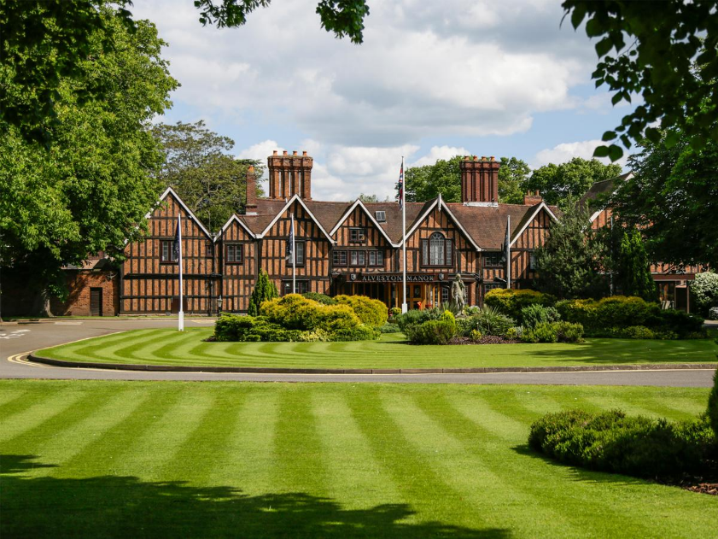

Our annual conference returns to Stratford-upon-Avon this October!
Book your place on the national middle school event that is not to be missed

Middle School people talking about Middle School education

Keynote Speakers

 | 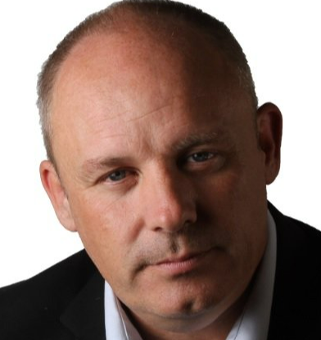 | 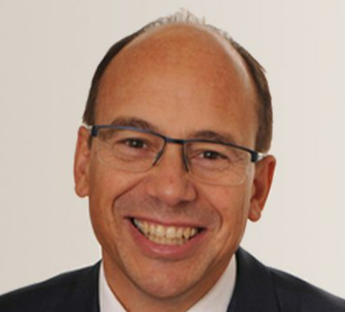 | 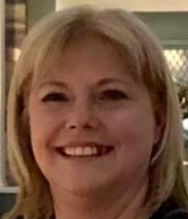
Pam Burrows  The People Booster | Robin Launder  Motivation Matters | Andrew Warren  Regional Schools Commissioner | Sandy Hayes  Senior HMI  Ofsted

Book now to reserve your place and be part of the only conference of its type
that focuses on your school

www.middleschools.org.uk

